**Test Plan for Bird ID App**

**Basic Purpose of the App**

The Bird ID App is an application that can run on IOS, Android, and Microsoft Windows. It allows the user to identify birds by narrowing down their characteristics. This test plan focuses on the Android version.

**Test 1 Basic Navigation**

1. When you open the app, you should see the following screen:

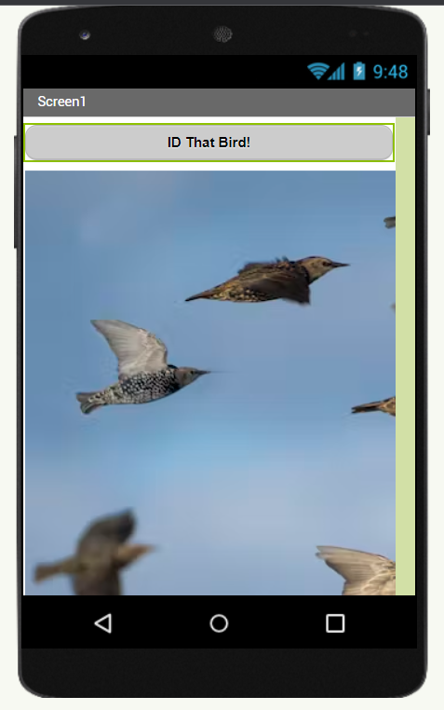

1. Click on the “ID That Bird!” button. You should see this screen:

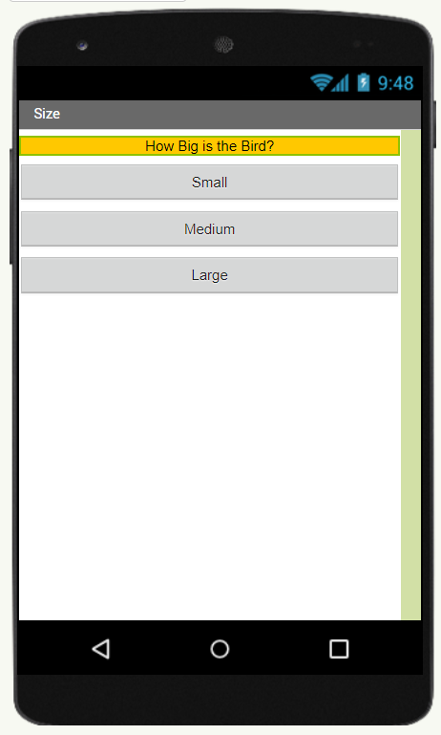

1. Click on the “Small” button. You should now see this screen:

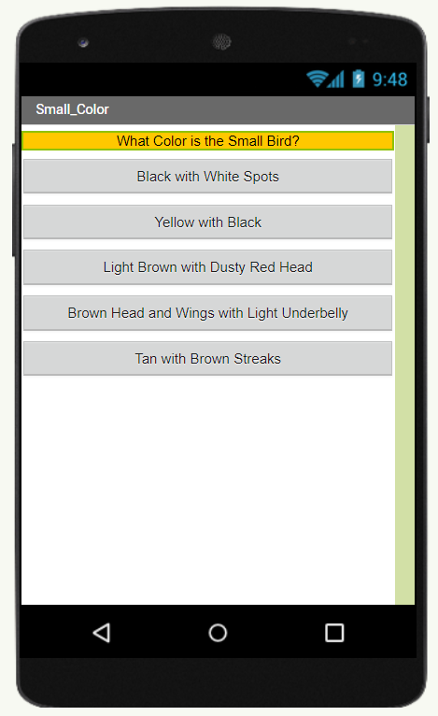

1. Click on the “Light Brown with Dusty Red Head” button and you should see this screen with a labelled picture of the bird you just identified:

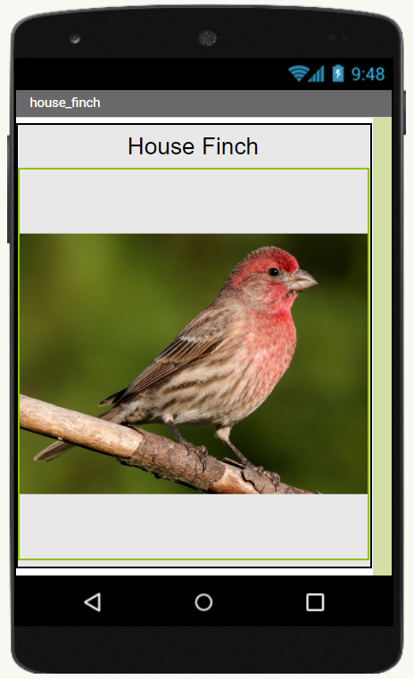

1. From the “What Color is the Bird?” you can also navigate to the “American Goldfinch” page using the “Yellow with Black” button.

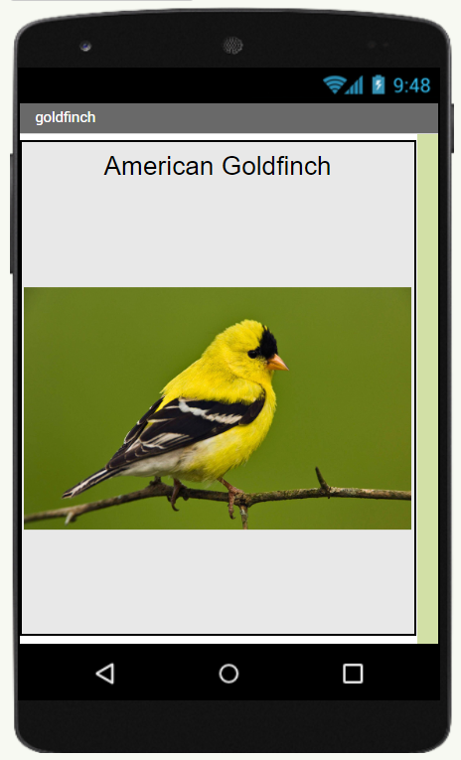

1. From the “What Color is the Bird?” you can also navigate to the “Downy Woodpecker” page using the “Black with White Spots” button.

